Electricity Usage Prediction Using XGBoost: DMS Method
Ilham Maroof Sutrisno
¹ Energy systems engineering program, School of Electrical Engineering, Telkom University, Bandung, Indonesia
² Centre of Excellent Sustainable Energy and Climate Change, Telkom university, Bandung, Indonesia

*E-mail: erixno@telkomuniversity.ac.id

Abstract. This research presents the design and implementation of a portable real photovoltaic simulator (PVRS) integrated with Internet of Things (IoT) technology as an interactive learning medium. The system was built using an Arduino Mega 2560 microcontroller as a controller, which interfaces with sensors to measure solar irradiance, temperature, voltage, and current. Measured data are processed and transmitted in real time to a computer through serial communication and displayed it in an interactive graphical user interface (GUI). The GUI was developed using LabVIEW software to display graphically the measured data as well as record the data locally. To connect between the controller and the GUI, a simple protocol was also developed for data transmission. The system also supports local data storage through an SD card module and time synchronization using an RTC module, with additional real-time monitoring capabilities through a web interface. Experimental testing was conducted using both series and parallel PV panel configurations under varying irradiance levels. Results showed that the series configuration provided higher voltage but lower current, while the parallel configuration produced higher current but lower voltage. This simulator not only enables to observe and analyze PV performance directly through real-time data visualization but also enhances conceptual understanding of solar energy systems, electrical configurations, and the role of IoT in energy monitoring. The developed system proves to be a valuable and accessible educational tool for renewable energy learning and experimentation.
1. Introduction
The urgency of adopting renewable and sustainable energy is driven by the need to reduce climate change and dependence of fossil fuel usage. Buildings are the staple of civilised society, they are where we conduct our activities whether that may be resting at home, working at the office, or leisure at the malls. Thus building are the number one energy consumer of today’s society, making them the ideal target for improving energy efficiency. Predicting energy usage and then adapting current loads to be online when most of the energy generated by the grid is using renewable and sustainable sources is a viable method for increasing a building’s energy efficiency. Utilizing more energy while renewable sources, like wind or solar, ar at their peak will reduce the usage of energy originating from fossil fuel-enabled power stations.
One example of a system that can be used during renewable peak hours and ramped down during non renewable peak hours is air-conditioning. By setting the target temperature of an HVAC system lower during renewable peak times and higher during non peak times, the HVAC system will be utlilizing more energy generated by renewable means.
Campus buildings may use the foresight to decrease loads during hours where the renewable energy is not at its peak generation times.

The urgency of adopting renewable energy is driven by the need to combat climate change and reduce dependence on fossil fuels. Photovoltaic (PV) technology stands out as a key solution, harnessing abundant solar energy to produce electricity with minimal environmental impact. Its scalability, decreasing costs, and advancements in efficiency make PV increasingly viable. For countries like Indonesia, investing in PV technology supports both energy needs and the transition to a low-carbon future, making it a crucial focus in renewable energy education.
Renewable energy education is becoming increasingly crucial in increasing social awareness regarding its advantages to reduce dependencies on fossil fuels and address climate change. In Indonesia, the need of comprehensive education on renewable energy, particularly photovoltaic (PV) technology, is urgent, from academic to industrial level, understanding how solar energy can be effectively generated and utilized will assist students with essential knowledge to contribute in increasing their soft skills. However, Indonesia currently faces significant limitations in terms of educational modules and teaching kits that adequately support this learning process.
The role of photovoltaic (PV) systems in renewable energy education has been extensively explored, with numerous studies highlighting the need for specialized educational tools and modules. One significant development is the Illuminator, an open-source energy system designed to facilitate the understanding of complex energy transitions by Aihui Fu (2023). This tool, developed for education and demonstration purposes, provides a flexible and modular approach to energy system integration, allowing for a variety of educational cases to be explored. Unlike traditional engineering tools such as Digsilent PowerFactory or Matpower, which are tailored for advanced users, the Illuminator is specifically designed to be accessible for educational purposes, offering a more intuitive interface that can be used to teach energy system concepts to a broader audience.
In addition to the Illuminator, other educational kits and tools have been developed to address the challenges of teaching photovoltaic technology. For instance, the development of a simple, low-cost PV panel characterization kit using Arduino by R.Ramaprabha (2021) has shown significant promise. This kit allows for real-time monitoring of PV module characteristics under varying temperature and irradiation conditions, which are critical factors in PV system performance. The kit's design enables students to simulate and validate MPPT (Maximum Power Point Tracking) algorithms using Matlab/Simulink, thereby providing a hands-on learning experience that enhances their understanding of PV system operations.
Moreover, other research efforts have focused on developing more sophisticated PV system models that can be used in educational settings. For example, studies have explored the use of single diode models for simulating the I-V characteristics of PV modules, taking into account the effects of temperature and solar radiation. These models are crucial for understanding the behavior of PV systems in real-world conditions and have been integrated into educational modules that allow students to experiment with different configurations and optimization techniques. Such research underlines the importance of providing students with tools that not only teach theoretical concepts but also offer practical insights into the complexities of renewable energy systems.
2. Development of Monitoring and Prediction System
The system is designed to predict the next 24 (1day), 72(3days), and 168(7days) hours of electrical usage by the building. It can relay the completed prediction data via online means through a website.
2.1 Development of The Energy Measurement System
Development first starts with the monitoring system that will be feeding the training and realtime data for the prediction algorithm. The monitoring system is made up of a PZEM-004T that is responsible for measuring the voltage and current of the circuit (current measurement is conducted using a current transformer), an ESP32 microcontroller unit that is responsible for calculating the energy usage from the voltage and current measurements as well as sending the energy usage data to the cloud platform, which in this case is Antares.
2.2 Development of The Prediction System
A PC or laptop will then fetch the data from Antares and store it in the local Sqlite database for model training and prediction. The model used is XGBoost, an ensemble learning algorithm that uses a gradient boosting framework to combine the predictions of multiple decision trees.
To correctly leverage this algorithm for predicting electricity usage of a building, features will be made that suit the prediction. Those features are the hour of day, day of week, day of month, is_weekend, temperature, and lag features for each prediction window. Before training the model using the data measured from the sensor through Antares, rudimentary data cleaning is done in the way of imputing any missing monitoring data. After that is done the model training can begin.
DMS (Direct Multi Step) is a strategy that uses multiple separate, independent model to predict each step into the future (in this case each hour). This is used to circumvent the need to generate the features for each future timestamp, allowing XGBoost to only need the prediction timestamp and temperature to predict the energy usage. The system is designed to be retrained every end of the week so that the model can continually improve without the need for manual intervention.
The front-end for this system uses Flask and HTML to host the website that will display and control which prediction window to use, also to display other information such as model performance and to trigger manual model retraining.
Development of the PVRS including hardware and software, whereas the study was started with comprehensive system design as in the Figure 1. The system in this portable solar panel is designed to support real-time performance monitoring and consists of several integrated main components. The central component of this system is the Arduino Mega 2560 microcontroller, which serves as the main controller. The microcontroller functions as a reader for data from various sensors, including a temperature sensor to monitor PV thermal conditions, a irradiance sensor to measure the amount of solar irradiance received by the panel, as well as voltage and current sensors connected to the microcontroller to track the electrical performance of the PV. In addition, the microcontroller is connected to supplementary components such as an LCD display, which shows data directly to users on-site, a Real-Time Clock (RTC) module for accurate timestamping of data collection, and an SD card module that stores historical data locally in a format suitable for further processing.
The system uses LabVIEW software to develop a Graphical User Interface (GUI) as a visual user interface for monitoring and further data processing. The Measured Data obtained from the microcontroller is transferred to the developed GUI via serial communication over a USB cable. The microcontroller builds a packet containing header and the measuring data as shown in Figure 2 before it transmits the packet to the GUI. In the GUI, the packet is unpackaged to obtain the measured data and then display in real-time on the GUI. In addition, the GUI has capability to store the measured data for further analysis. To increase the system's flexibility, monitoring data can also be uploaded to a web platform through an internet connection, allowing users to access solar panel performance data remotely using PCs, laptops, or mobile devices. This system supports real-time and distributed monitoring, making it highly suitable as an interactive learning platform based on the Internet of Things (IoT).
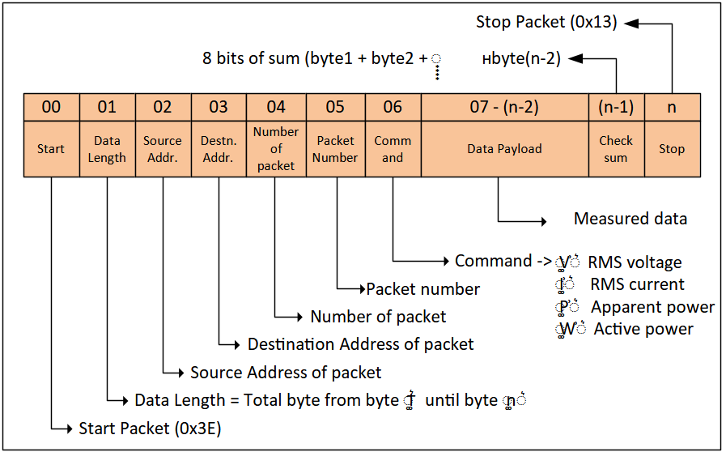
Figure 2. A protocol design for data communication between the microcontroller and the GUI
For reading analog signals such as voltage and current, the Arduino Mega 2560 utilizes its Analog-to-Digital Converter (ADC) feature. This feature converts analog signals from the sensors into digital data that can be further processed by the microcontroller. To ensure efficient communication between devices in the system, the Arduino also uses RS485 serial communication, which allows for long-distance data transmission with high reliability and minimal interference. Overall, this system not only functions as a performance monitoring tool for portable solar panels but also serves as an educational platform that enables users to understand the working principles of renewable energy systems and the application of IoT-based monitoring technologies firsthand
BERIKAN PENJELASAN GAMBAR DIBAWAH (1 paragraf)
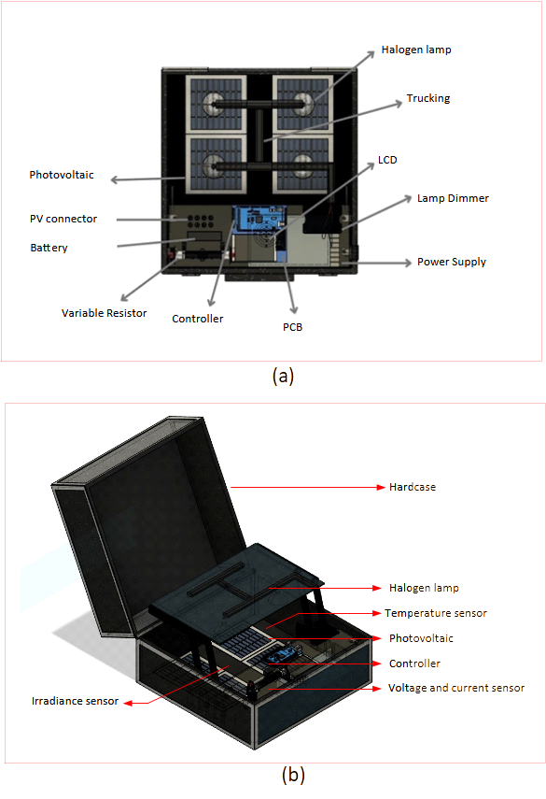
Figure 3. 3D design of PVRS hardware: top view (a) and perspective view (b)
4. Result and discussion

xx

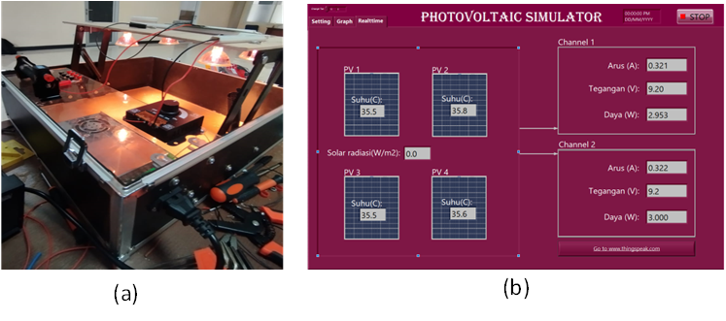
Figure 4. The PVRS hardware (a) and it’s GUI
The performance evaluation of the photovoltaic real simulator (PVRS) system was conducted under two different electrical configurations: series and parallel connections. Data were collected at varying levels of solar irradiance ranging from 100 to 500 W/m², with parameters such as voltage, current, and power output measured under both short circuit and resistive load conditions. In the series connection setup as in the Table 1, the voltage increased gradually with increasing irradiance, from 16.42 V at 100 W/m² to 18.42 V at 500 W/m² under short circuit conditions. Currently it also rose steadily from 1 mA to 6 mA in short circuit, and from 1 mA to 5 mA with a 4-ohm resistor. The power output under short circuit conditions showed a significant increase, from 16.42 mW to 110.52 mW, while under the 4-ohm load, it only increased from 0.008 mW to 0.145 mW. These results highlight that the series configuration is more favorable for voltage-driven applications, although the power output under load remains relatively low, likely due to limitations in current handling and mismatched resistance.

Table 1. The result for the series connections

In contrast as shown in Table 2, the parallel connection demonstrated a higher current output, which is typical for this configuration. While the voltage remained lower than in the series setup—ranging from 7.9 V to 9.13 V—the current increased more significantly, especially under load, from 3 mA to 13 mA with a 2-ohm resistor. Power output also showed strong performance, rising from 23.70 mW to 109.56 mW under short circuit conditions, and from 0.027 mW to 0.494 mW with the 2-ohm resistor. These results indicate that the parallel configuration is more efficient for current-demanding applications, especially under low resistance loads.

Table 2. The result for the parallel connections

Overall, both configurations displayed an expected increase in electrical performance with higher irradiance. However, the parallel configuration consistently delivered better power output under load conditions, making it more suitable for practical applications. The series configuration, while effective at delivering higher voltage, showed limited power under resistive loads, possibly due to internal resistance or load mismatch. Therefore, depending on the intended use—voltage-demanding or current-demanding—the appropriate wiring configuration should be selected to optimize the performance of the portable solar panel system.

5. Conclusion
This study successfully demonstrates the development and evaluation of a photovoltaic real simulator (PVRS) as a learning medium based on the Internet of Things (IoT). Through experimental testing using both series and parallel solar panel configurations, it was found that solar irradiance significantly affects the output current, and power of the system. The series configuration produced higher voltages but lower current under resistive loads, indicating its suitability for applications that require higher voltage. In contrast, the parallel configuration delivered higher current and lower voltage under load. Implementation of PV in series and parallel connection depends on the application.
Integrating this system with the GUI developed by LabVIEW and IoT capabilities allowed for real-time monitoring and data logging, which enhances its value as an educational tool. Users can observe how different irradiance levels and configurations affect PV performance directly via a computer interface, LCD panel, or web-based access.
Therefore, this simulator not only functions as a reliable and portable solar energy testbed but also provides an interactive and data-driven learning experience for students and practitioners. It highlights the critical role of system configuration in PV performance and offers a practical platform for understanding renewable energy systems within the context of IoT-based monitoring and control.

Acknowledgement
The authors thank the technical and financial assistance support from Telkom University for publishing this research under grant with a number of 337/LIT06/PPM-LIT/2024.

References
- A. Allouhi, S. Rehman, M. Buker, and Z. Said, "Up-to-date literature review on Solar PV systems: Technology progress, market status and R&D," *Journal of Cleaner Production*, vol. 2022, Aug. 15, 2022.
- M. Vallon, L. Gao, F. Jiang, B. Krumm, J. Nadolny, J. Song, T. Leisner, and H. Saathoff, "LED-based solar simulator to study photochemistry over a wide temperature range in the large simulation chamber AIDA," *Atmospheric Measurement Techniques*, vol. 15, no. 6, pp. 1795–1810, Mar. 25, 2022.
- R. Ramaprabha, T. Tamilselvi, C. A. Kowsalya, V. Associate, and P. Student, "Implementation of simple low cost PV panel characterization kit using Arduino," pp. 6991–7003, 2021.
- M. Jalil, D. Sharma, and R. Bansal, "Cross kit reconfiguration algorithm for enhanced output power of PV array during shading mismatch conditions," *Optik*, vol. 288, Oct. 2023.
- A. Fu, R. Saini, and M. Cvetkovic, "The Illuminator: An open source energy system integration development kit," in *2023 IEEE Belgrade PowerTech, PowerTech 2023*, 2023.

